Relational Databases with MySQL Week 4 Coding Assignment

**Points possible:** 70

|  |  |  |
| --- | --- | --- |
| Category | Criteria | % of Grade |
| Functionality | Does the code work? | 25 |
| Organization | Is the code clean and organized? Proper use of white space, syntax, and consistency are utilized. Names and comments are concise and clear. | 25 |
| Creativity | Student solved the problems presented in the assignment using creativity and out of the box thinking. | 25 |
| Completeness | All requirements of the assignment are complete. | 25 |

**Instructions:** Using a text editor of your choice, write the queries that accomplishes the objectives listed below. Take screenshots of the queries and results and paste them in this document where instructed below. Create a new repository on GitHub for this week’s assignments and push this document, with your Java project code, to the repository. Add the URL for this week’s repository to this document where instructed and submit this document to your instructor when complete.

**Coding Steps:**

Write 5 stored procedures for the employees database.

Write a description of what each stored procedure does and how to use it.

Procedures should use constructs you learned about from your research assignment and be more than just queries.

**Screenshots:**

1. **GetNamesByTitle – if you run this procedure and pass into it a specific job title (e.g. Staff, Engineer, etc.), it will return the employee number, and first and last name of each person with that title**

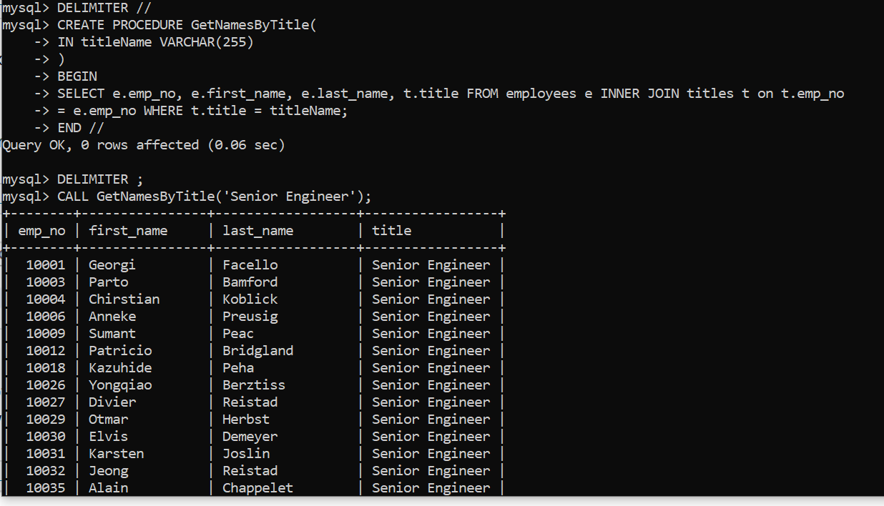

1. **GetNumberByName – when you pass in a first name, this procedure will output the number of employees with that specific first name**

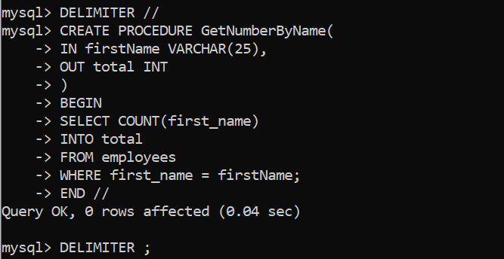

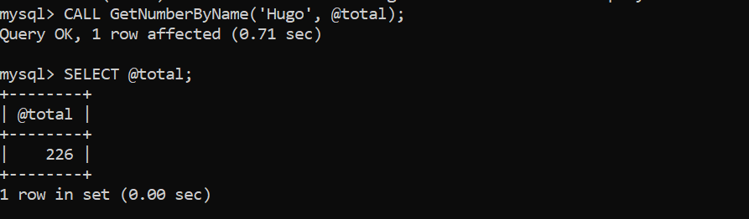

1. **GetSalaryStatus – in theory, this procedure will allow you pass in an employee number and it will return “Low,” “Mid,” or “High” which corresponds to their salary. However, when I created this, I didn’t realize that the salaries table uses the same employee number for several entries because each employee could have had different salary amounts in the past…**

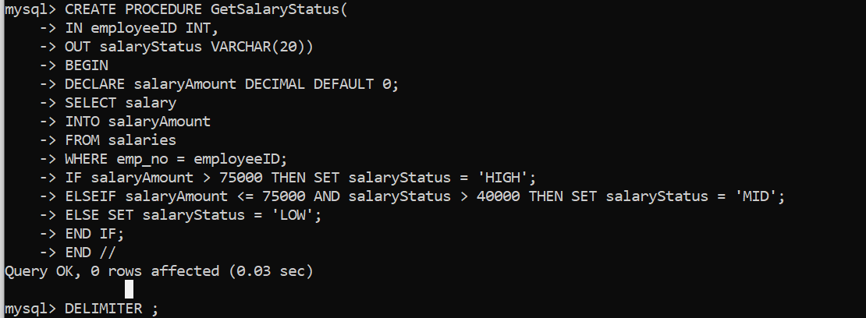

**4.GetDeptName – this procedure will output the department name that a specific employee belongs to when you pass in their employee number**

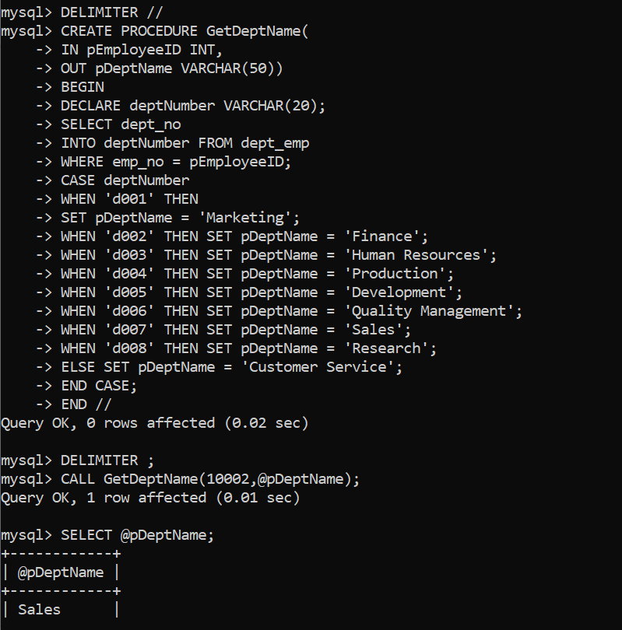

**5.GetNumberPerTitle – when you input a specific title, this procedure will output the number of people who have that title**

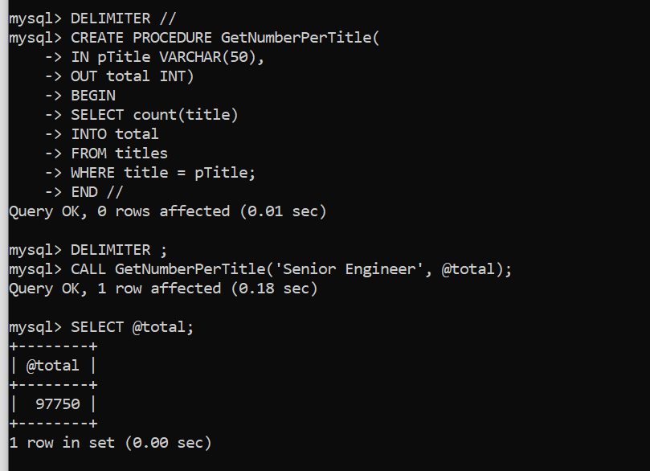

**URL to GitHub Repository**

**https://github.com/AprilHawthorne/mySQLWeek4.git**